MS-P-0200 - Developing a population model for Rum Manx Shearwaters for assessing offshore wind farm impacts and conservation measures

Written by Jason Matthiopoulos & Robert W. Furness with contributions from steering group members Kate Thompson, Lesley Watt, Sue O’Brien and external evaluator Kate Searle.

|  |  |
| --- | --- |
| Date: | 11th December 2023 |
| Tel: | 0141 342 5404 |
| Web: | [www.macarthurgreen.com](http://www.macarthurgreen.com) |
| Address: | 93 South Woodside Road |Glasgow | G20 6NT |

Document Quality Record

|  |  |  |  |
| --- | --- | --- | --- |
| Version | Status | Person Responsible | Date |
| 0.1 | Draft | Jason Matthiopoulos | 12/04/2023 |
| 0.2 | Reviewed | Bob Furness | 18/04/2023 |
| 1.0 | Revisions following steering group comments | Jason Matthiopoulos | 11/12/2023 |

This report has been subjected to an independent external review commissioned by the Marine Directorate and Offshore Wind Directorate.

|  |  |  |
| --- | --- | --- |
| MacArthur Green is helping to combat the climate crisis through working within a carbon negative business model. Read more at [www.macarthurgreen.com](https://www.macarthurgreen.com/our-carbon-negative-business-model). | | |
|  |  |  |

CONTENTS

1 Executive SUMMARY 4

2 introduction 5

3 Methods 6

3.1 Data availability 6

3.2 Survey data 7

Population monitoring and area mapping study from 1960s-1970s (Wormell (1976)): 7

Population monitoring study from 1979 (Thompson and Thompson (1980)): 7

Population monitoring study from 1982 (Philips 1982): 7

Population monitoring studies from 1990 & 1995 (Furness 1990, 1997): 8

Population monitoring study from 2001 (Murray et al. 2003) 8

MarPAMM 2022 (Inger et al. in prep. Report to Marine Scotland): 8

3.3 Demographic data 8

Life history: 8

Dispersal: 8

Breeding success: 9

Adult survival: 9

Juvenile survival: 9

3.4 Covariate data 9

Density dependence: 9

Rainfall: 10

3.5 Modelling 10

Population surveys: 12

Demographic data: 12

Prior specification: 12

Addition of data from playback surveys: 12

Addition of breeding data from Canna: 12

3.6 Fitting to real data 13

3.7 Validation with simulated data 13

3.8 Sensitivity on population estimates 13

Model 2: 14

Model 3: 14

Model 4: 14

Model 5: 14

3.9 Examination of covariates 14

3.10 Forecasts 14

4 Results 15

4.1 Baseline model 15

4.2 Validation with simulated data 15

4.3 Sensitivity analysis 16

Model 2: 16

Model 3: 16

Model 4: 17

Model 5: 17

4.4 Effect of rainfall 18

4.5 Forecasts 19

Effects on adult survival: 19

Effects on fecundity: 20

5 Discussion 21

6 References 24

# Executive SUMMARY

The Isle of Rum (Scotland) holds 25-30% of the world’s Manx shearwater population. It is currently unclear whether this internationally important and relatively isolated sub population is increasing or not, and whether it would be vulnerable to proposed marine renewable developments in its vicinity. In this work, we undertook a detailed review and collation of available historical and current data for Manx shearwaters on Rum and synthesised them into an integrated population model that allowed us to reconstruct population trends and quantify future sensitivities.

We found extensive and precise information for several demographic processes (especially breeding success and adult survival) and baseline rates. The availability of survey data, directly estimating the population size is limited, intermittent and of variable (often low) precision. Availability of weather covariates is unexpectedly patchy (i.e., not collected from the same sources), but extensive. Data for key covariates of concern, such as proxies of rat abundance are very recent (hence of limited value, since their consequences may not yet have become manifested in the population data) and do not coincide with data on breeding success.

For our modelling, we adopted a Bayesian state-space model because it allowed us to 1) integrate diverse data types, collected by different field methodologies and 2) represent different forms of uncertainty and stochasticity in our results and projections. This approach therefore achieves the fine balance of maximising precision (by using all data available) without overestimating confidence (by correctly propagating uncertainty to the final results).

The population part of our state-space model incorporates essential facts about Manx shearwater life history (e.g., generational lags) as well as environmental and density-dependent constraints to growth. The simplest version of the model contains no environmental covariates, opting instead to represent extrinsic drivers by random effects in breeding and survival. More elaborate extensions of the process component of the model illustrate how a partially observed covariate (rainfall) can be incorporated into demography.

The observation part of our state-space model considers the features (limitations and advantages) of all the field data. We consider bias and precision in population estimates, particularly regarding the most recent and statistically influential studies. We perform a sensitivity analysis by relaxing the reported level of precision in different parts of the observation data and proceed with a precautionary version of the model that includes previously omitted sources of uncertainty.

The modelling approach was validated by fitting the model to synthetic data of a similar nature and extent to the currently available real data. This validation exercise suggests that the available data are sufficient to accurately and precisely retrieve hidden parameters and to reconstruct latent population trends in partially observed or wholly unobserved demographic time-series.

Such reconstructions, generated from the real data indicate that the population has been increasing since the 1980s but may now be starting to experience the effects of density dependence. We extend the temporal horizon of the model to a 100-year forecasting range and run several counterfactual scenarios relating to anthropogenic impacts on adult mortality and fecundity. These experiments indicate that the population would be robust to very strong pulse perturbations (e.g., 50% adult mortality and complete failure in fecundity), but would be vulnerable to sustained, press perturbations in the survival of adults.

We conclude by discussing possible approaches to survey data imprecisions, the future inclusion of other covariates and the development of a detailed model for density dependence more appropriate for the biology of burrowing seabirds.

# introduction

The Manx shearwater (*Puffinus puffinus*) population situated in the mountains of Rum is of international importance. Given proposed offshore wind developments in the north-west region of Scotland’s seas, this population is at potential risk from associated impacts and may also be affected by changing environmental variables at the colony or at sea (e.g. arising from climate change). The global breeding population is estimated at between 744,700 and 1,222,500 pairs of which the colonies in Britain and Ireland hold between 712,010 and 1,184,800 pairs or some 96% of the total (Burnell et al. 2023). It can therefore be considered as the most endemic of all seabirds breeding in these islands. There are relatively few colonies (50 in total in Britain and Ireland) but 80% of the population is concentrated in Pembrokeshire (Skokholm and Skomer) and on Rum, with some uncertainties around population estimates at all three colonies (Burnell et al. 2023). In particular, the most recent estimate for the Rum colony (Inger et al, 2022) is substantially larger than previous estimates, as is discussed in detail later in this report. Nine islands off Kerry in SW Ireland hold a further c.14% of the British and Irish population. There is limited information on metapopulation structure, but it is expected that some transfer of young birds to other colonies occurs. Adult breeders normally return to the same burrow each year if breeding is successful but may move to a nearby burrow if they fail.

There is currently little overlap between Manx shearwater at-sea distribution and existing offshore wind farms (installations in the Irish Sea are unlikely to be an important area for birds from Rum, although birds from Rum do use the Irish Sea front area (Guilford et al. 2019) However, some of the lease areas of the ScotWind programme will see developments in areas used by Manx shearwater. Possible displacement/barrier effects are always a risk but another concern (Syposz 2020) is that fledgling shearwaters can be attracted to the safety lights used by wind farms to warn aircraft and wider interactions with lighting at sea are uncertain (Deakin et al. 2022). It is therefore important to develop a baseline for this population, to evaluate risk with as much precision as the current aggregate data allows and to produce a population model that generates predictions of how the Rum population may respond to additional mortality/reduced breeding success arising from anthropogenic factors.

This project aimed to apply Bayesian state-space modelling to relevant available data including surveys of the Rum population, long term but discontinuous monitoring of burrow occupancy and breeding success in small sample areas, ringing records, weather data and previous studies of rat depredation and rainfall effects. The overarching scientific objective was to construct a robust model of the dynamics and drivers of the Rum shearwater population. Work package references can be put into context by referring to Table 1.

**Table 1:** Work package structure for the entire project, included here for reference.

|  |  |  |  |
| --- | --- | --- | --- |
| ***WP1*** | ***Data collation*** | ***1.1*** | Formatted data frame of available survey, demographic and covariate data |
|  |  | ***1.2*** | Accompanying prior precision estimates for each datum |
|  |  | ***1.3*** | Report on the aspects of the observation process that yield inaccuracies and imprecisions |
|  |  | ***1.4*** | Reporting on the derivation of parameter priors on the basis of expert opinion |
| ***WP2*** | ***Model development*** | ***2.1*** | Technical report of model specification, model equations and likelihood subfunctions |
|  |  | ***2.2*** | Simulation and model fitting code (in R and JAGS respectively) |
|  |  | ***2.3*** | Validation diagnostics of model performance with simulated but realistic data |
| ***WP3*** | ***Covariate exploration*** | ***3.1*** | Results on strength of various covariates and association with individual demographic rates |
|  |  | ***3.2*** | A firming-up of the baseline demographic rates and the age-to-recruitment for this population |
| ***WP4*** | ***Trajectory reconstruction*** | ***4.1*** | Report on the trajectories for population size and three demographic rates |
| ***WP5*** | ***Forecasts*** | ***5.1*** | Forecasts and associated credible intervals, including scenarios for AI and windfarm effects |
|  |  | ***5.2*** | User-friendly, open access simulation R-code for use by stakeholders |
| ***WP6*** | ***Expandability*** | ***6.1*** | A review and report on the framework’s scalability, expandability and compatibility. |
| ***WP7*** | ***Reporting*** | ***7.1*** | Formal report (MS Word) |
|  |  | 7.2 | Topic sheet (MSWord) |
|  |  | 7.3 | Technical vignette (PDF or HTML, as preferred) |
|  |  | ***7.4*** | R, JAGS, Markdown code |
|  |  | ***7.5*** | Oral presentation |
|  |  | ***7.6*** | Hands-on practice with the framework and generation of forecasts and counterfactuals |
| **WP8** | **Peer reviewed paper** | ***8.1*** | Publication in high-quality applied ecology journal |

# Methods

## Data availability

Our survey of available data prioritised use of peer-reviewed results. Since we aimed to understand how the population functions, rather than just producing a current snapshot of its composition and size, we considered historical information to be just as valuable as recent data. Information extracted from publications was of a numerical nature (estimates, confidence intervals, timing and extent of effort), but also descriptive. Descriptive information provided clues about the reliability of these numbers and the possibility of their integration into the study. For example, any indication from the methods description that not all sources of uncertainty had been included in statistical estimation would lead us to treat the confidence interval in the estimate as potentially too narrow. Unpublished reports, working papers, consultations, published government reports or raw data were used as sources of the population’s most recent status. It is particularly relevant that several of the observations provided for the same biological variables have been obtained via different methods, so they are not directly comparable without some form of scaling or calibration.

## Survey data

Manx shearwaters are burrow-nesting or cavity-nesting seabirds that only return to the colony at night. This makes them notoriously difficult to count (Murray, et al. 2003, Bolton and Thompson 2023). Rum has been difficult to survey accurately and so the population size and the direction and shape of the population trend are rather uncertain. Ringing-recapture methods are generally considered ineffective for estimating population size (Wormell 1976) and therefore the population size is estimated by a calculation involving observations on apparently occupied burrows (AOB) per unit area surveyed and an estimation of the overall area of the colony. The density of burrows appears to remain consistent across surveys but the area of ground occupied is highly uncertain and estimates differ considerably so that the total numbers depend primarily on the estimated occupied area of the colony.

It is relevant to note that Manx shearwater burrows at Rum tend to be long (often about 2 m from entrance to nest chamber). The ground in which the burrows are dug is very hard gravelly sand and rock. Burrows are often dug under or around loose rocks that are too large for shearwaters to move. Excavating these burrows must take a lot of time, and probably is the effort from several years of digging before a burrow is fit to use for breeding. This means that growth in breeding numbers may be constrained by the number of burrows, and especially by the number of high-quality burrows that provide protection from flooding and from predators/disturbance. Similarly, if the population were to decline, burrows would not disappear quickly, but would remain obvious in the terrain for many years. Therefore, a decline in breeding numbers would result in a higher proportion of unoccupied burrows rather than a large decrease in the number of burrows. These points are relevant to consider in relation to the large variations in estimates of colony size from surveys carried out between the 1960s and 2020s.

Relevant data identified included:

Population monitoring and area mapping study from 1960s-1970s (Wormell (1976)): Carried out detailed mapping and characterisation of the vegetation associated with suitable burrow habitat (the shearwater greens). An estimate of the total area of shearwater greens was made by aggregating all the greens from vegetation surveys carried out between 1961 and 1964 with the help of aerial photographs taken in earlier years. The density of burrows was surveyed in different compartments on the island in 1965 to 1969.

Population monitoring study from 1979 (Thompson and Thompson (1980)): Used the same overall approach and calculation of colony area as (Wormell 1976) with a different set of random quadrats for collecting data on burrow density and occupancy. They found a mean burrow density 21% higher than in any other survey, a result that may easily have occurred if their quadrats tended to be placed in the more densely populated shearwater greens (Murray et al. 2003).

Population monitoring study from 1982 (Philips 1982): Used the same calculation of colony area as (Wormell 1976) but with a different set of random quadrats for collecting data on burrow density and occupancy, again following essentially the same survey protocol. Burrow densities estimated by (Philips 1982) were lower than those in (Wormell 1976) and (Thompson and Thompson 1980).

Population monitoring studies from 1990 & 1995 (Furness 1990, 1997): Two surveys conducted using the same methodology (105 quadrats, 10mx10m size). Burrows were classified into used and unused. The proportion of burrows assessed as unused in the 1990 and 1995 surveys was higher than seems to have been the case in (Wormell 1976). The estimated area of the colony was similar to the area derived by (Wormell 1976). The confidence intervals of the later surveys were considerably larger because they included uncertainty in the estimation of areas (as well as sampling uncertainty in the estimation of burrow density).

Population monitoring study from 2001 (Murray et al. 2003): Estimated occupancy rates of burrows based on visual cues at burrow entrances (droppings, feathers etc.) and on responses to tape playback of Manx shearwater calls. An estimate of colony extent was based on the total area of ground above the 457m altitude contour. The area considered was dramatically larger (4.5 times) than the previous estimates of the colony extent. Estimates of population size were consequently also higher, but not proportionately so (2 times). The estimate was derived from a stratified survey distinguishing between high-density core areas and lower density peripheral areas. A parallel method of data collection using tape playback was undertaken and a correction factor of approximately 1.9 was applied to account for non-responding birds. This may have been a low correction since a similar study using visual and acoustic methods carried out on Welsh populations (Smith et al. 2001) found that response rates are between 0.3 and 0.53 (implying corrections in the range 1.9-3.3).

MarPAMM 2022 The report by Inger et al (2022) estimates a much higher number of Manx shearwaters at Rum than previous counts. The estimate is based on a very similar mean density of burrows within quadrats but a very much larger estimate of colony area (characterisation of the colony area was based on habitat suitability modelling, rather than direct survey). Statistical concerns about this estimate are the lack of validation/ground-truthing of the habitat model, and the partial propagation of uncertainty to the end results.

## Demographic data

We considered the following aspects of demography:

Life history: The earliest age to reproduction, as inferred by early studies (Harris 1966, Brooke 1977) on the rates of return by young shearwaters is approx. 5 years. These data indicate the possibility of birds being found for the first time in later years and this could be an artefact of detectability, or a result of postponed breeding due to density-dependent limitations (see section on density dependence below). A discussion on the limitations of this estimate (Horswill and Robinson 2015) also includes the possibility that some of the birds in these early studies had actually bred undetected at age 4.

Dispersal: There is some evidence that the levels of breeding dispersal in the species are low (Harris 1966, Brooke 1978, Horswill and Robinson 2015). This permits the assumption of a closed population, allowing us to attribute all adult losses to mortality, and also to assume that all new recruitment comes from recruitment of juveniles. It is less clear whether cross-subsidies of juvenile recruits from nearby colonies are substantial. However, levels of productivity in the most proximate colony at Canna are lower than at Rum (Thompson and Furness 1991), making Rum a source population (hence, one donating surplus individuals that are unlikely to have an impact on a model of a closed population).

Breeding success: Baseline information on the rates of breeding can be derived from estimates of breeding propensity (Newman et al. 2021, Wood et al. 2021) as well as studies carried out elsewhere (Brooke 1977, 1978, Mavor et al. 2006, Booker et al. 2008). Time series of breeding success (counts of nests with successful reproductions) come from multiple reports for Rum (Thompson and Furness 1991, Wood et al. 2021) and the neighbouring colony at Canna (Thompson and Furness 1991). The time series on breeding success on Rum spans the years 1958-69, 1971, 1973, 1985-86, 1994-2018. Sampling effort varies from ~30 nests in the early years, up to 221 in 2014. Data on breeding success of Manx shearwaters on Canna ((Thompson and Furness 1991) and JNCC SMP database, now hosted by BTO at <https://app.bto.org/seabirds/public/index.jsp>) exist for the period 1973-81, 1982-85. These can be used as a relative index of productivity for the missing years of data on Rum, but not a simple proxy since productivity on Canna is generally lower.

Adult survival: There is good baseline information on adult survival from various sources (Perrins et al. 1973, Brooke 1977, Horswill and Robinson 2015, Horswill et al. 2016, Wood et al. 2021). A previous analysis of ringing data (Duff 2011) has yielded a continuous time series of estimates with associated confidence intervals for the period 1994-2010. This is used as a product (i.e., treated as data for the state-space model, with associated uncertainty).

Juvenile survival: There is only baseline information for juvenile survival from three publications (Harris 1966, Perrins 2014, Horswill and Robinson 2015). The estimates are derived from different viewpoints. The (Perrins 2014) study provides an overall survival estimate for the fledgling and juvenile years, whereas the (Harris 1966) study provides an estimate for survival of 4y old juveniles. These estimates were used jointly by the model to inform a prior for 1st year survival. There is no information on annual variations in juvenile survival.

## Covariate data

A key consideration regarding the availability of covariate data is that we require as complete a time series of covariates as possible. Some intermittency can be addressed via data imputation by the model, but we should weigh the relative value of information contributed by a fragmentary covariate against the inferential cost of the additional degrees of freedom introduced by imputation. In this work, we examined an autocovariate (density dependence) and an external covariate (rainfall). In the discussion we examine future possibilities for inclusion.

Density dependence: (Thompson 1987) discusses possible mechanisms of density-dependent regulation. Her findings suggest that the availability of high-quality burrows (as defined with respect to vulnerability to flooding, see below) may act as a temporary or permanent barrier to population growth, mainly via its regulation of breeding success. It is not generally clear if density dependence in seabirds operates at the colony (i.e., through competition for nest site e.g. burrows) or at sea (i.e., through competition for food), but either of these may have a suppressing effect on reproduction.

Rainfall: There is evidence (Thompson 1987, Thompson and Furness 1991) that heavy rainfall events during the incubation period can impact the breeding success of birds at Rum. A monthly rain gauge at the colony was maintained for a number of years by the National Nature Reserve team. Additional data from a nearby area (Tiree; the closest continuously monitored site but about 60 km from Rum, but a low-lying island with much lower rainfall than in the hills of Rum) were used as complementary information to help with imputation of missing data on Rum.

In summary therefore, the available data for the model were:

A total of seven surveys (1976, 1979, 1982, 1990, 1995, 2001 & 2021), each with a reported 95% confidence interval, mainly relating to sampling variation. Each survey has a different method to estimate the size of the colony and the estimated colony area is also known (but subject to debate).

A single, additional tape-playback survey in 2001 to obtain an estimate of bird abundance via a radically different method to the survey inspection.

Direct or indirect prior knowledge about the four demographic baseline processes of interest (survival of adults, juveniles and fledglings as well as fecundity).

Several continuous years of data on productivity of sampled burrows. Different studies have observed different sample sizes. The period 1973-1993 is relatively sparse in such data from the Isle of Rum.

A contiguous period of estimates for adult survival (1994-2010), with associated standard errors.

A period of years between 1973 and 1985 where productivity was recorded for the neighbouring island of Canna.

Time series of rainfall data, available for different times of the year. Only a limited number of years exists for Rum itself, and more extensive uninterrupted data from other locations, such as Tiree. An integrated cross-calibration exercise of the rainfall data is therefore needed, to impute the missing Rum rainfall data.

Very short (5y) period of rat abundance index, not overlapping with data on breeding success.

## Modelling

The key modelling challenge of this study is in distinguishing between true ecological fluctuations and artefacts created by the changes in survey methodology and calculation. Strong points of the data set are the auxiliary measures of demographic rates (survival and fecundity) and body of expert knowledge from field ecologists who have been dedicatedly working on this population for several decades.

The first priority was to develop an *integrative model* that could accommodate all of the available demographic data, have capacity to evaluate multiple covariates and be supported by expert views. We adopted a Bayesian Integrated Population Modelling (IPM) approach (Buckland et al. 2007, Fieberg et al. 2010, Maunder and Punt 2013, Matthiopoulos et al. 2014, Zipkin and Saunders 2018). In particular, given the dynamical nature of the questions involved, we used a state-space model, which couples a model for the biological (i.e., generative) process together with a model for the observation (i.e., data collection) process.

Models are not solely informed by data inputs and expert opinions, but also by biological constraints. Here, these originate from the key principles of population dynamics. A key priority of our modelling therefore was to recognise such *mechanistic principles* and use an approach that explicitly incorporates constraints.

A further priority was to correctly *address uncertainty* in reconstructed parameters, system states, forecasts and counterfactuals. This requires us to tread a fine balance between acknowledging uncertainty of different forms at the information-input stage, but without being so agnostic that we end up ignoring basic biological principles and cause the model to fail (by e.g., not converging to an answer) because of lack of information.

Achieving the first modelling objective (data integration) can be done via a frequentist approach, but it is generally easier to achieve on a Bayesian framework. The Bayesian approach also affords a more flexible treatment of uncertainty in model predictions and is, by design, suited to the incorporation of expert opinion in the form of priors.

The model's state variable was the number of breeding females, or, alternatively, the number of active burrows in the population. We modelled population dynamics in discrete time at the annual scale. In principle, next year's population size will comprise surviving adults from this year and the new recruits (the survivors from the cohort of chicks produced 5 years ago). This was expressed as a stochastic model to allow for demographic stochasticity and random effects to absorb the effects of unknown environmental covariates or errors in the observation process.

The process of breeding success was, in later version of the model written as a function of rainfall, and its effect on population size was lagged by five years, to allow for the age-to-maturity in Manx shearwaters. Recruitment of maturing juveniles was constrained to be negatively dependent on current population density (compensatory density dependence - (Miller et al. 2019)). In the project’s technical report, we investigated theoretical extensions of this rudimentary form of density dependence to allow for the imbalances in processes of burrow-building and natural degradation.

We implemented stochastic (overdispersion) terms in the linear predictors of the model's demographic rates and allowed the model to estimate the extent of overdispersion in each demographic process. This is a good indicator of which process is currently most vulnerable to extrinsic variations, and therefore which process should be getting investigated in the future for inclusion of candidate covariates.

The recorded data are as much a result of biological processes, as they are of observation artefacts and effort. In this sense, state-space models require equivalent amounts of modelling effort for the specification of the observation component. A large part of integrated population modelling, particularly when the time series available are not complete, or overlapping, is the imputation of missing data. In some cases (e.g., reconstructing the time series of demographic rates in this model) the results of imputation are interesting in their own right. In other cases (e.g., filling-in gaps in covariate data), imputation is necessary to deal with nuisance variables or parameters.

Population surveys: All surveys recorded the density of burrows in selected regions and then scaled up to total population size by calculating the total area of the colony on the island. Different surveys took different approaches in the field, but also implemented a differing scaling-up calculation to derive population size. Two types of error are built into the given estimates, First, bias in the point estimate. Underestimates could result from consistently selecting low-density areas for the sample surveys. Overestimates could result from assuming that more areas are suitable, or currently contain burrows. Second, bias in the precision. Accounting for only some sources of uncertainty in the estimate could have led to a smaller-than-necessary CV. Being too precautionary about the sources of error could have the opposite effect. We addressed such issues with a critical evaluation of the field and estimation limitations of different surveys and an extensive sensitivity analysis of model performance on different levels of bias (see below).

Demographic data: Observed proportions of burrows surveyed that reproduced successfully were modelled while accounting for variable observation effort. Mark-recapture estimates of adult survival (Duff 2011) over the period 1994-2010 were used, together with their associated standard errors. There were no survival estimates for the fledgling or juvenile stages in the model, so the only information provided directly on those demographic rates was in the form of baseline priors. The full trajectories for all four demographic rates were reconstructed as latent variables by the model.

Prior specification: The key parameters of the process model that were supported from prior knowledge are the baseline demographic rates (baseline adult survival and juvenile survival). We used a precautionarily broad range for the priors of these parameters. Although we don't have direct information for first-year survival, an informative joint prior was constructed from the available information on compounded survival from birth to recruitment. Breeding success was well informed by the available data, so it was not advisable to constrain the intercept arbitrarily, especially since all the information available for the baseline fecundity comes from the fecundity data that are already used by the model.

Addition of data from playback surveys: During the 2001 survey (Murray et al. 2003), a parallel method of data collection using tape playback was implemented at a time of year when non-breeding burrow occupiers would not be an issue. A correction factor of approximately 1.9 was applied to account for non-responding birds. This may have been a low correction since a similar study using visual and acoustic methods carried out on Welsh populations (Smith et al. 2001) found that response rates are between 0.3 and 0.53 (implying corrections in the range 1.9-3.3). To make use of this survey datum, we inflated the estimated confidence interval for the call-back population estimate by accounting for the uncertainty in the response rate. This led to a mean estimate of 97945 and a CV of 0.175. It is worth noting that this calculation is over the same estimate for the area of the colony provided by (Murray et al. 2003) for the visual part of their survey.

Addition of breeding data from Canna: The data from Canna have two distinct advantages. First, they cover a time period characterised by data-sparsity on Rum. Second, they have a one-year overlap with breeding data on Rum, allowing at least a rudimentary calibration. Despite its proximity to Rum, Canna offers a different geomorphology and vulnerability to risks such as rats and flooding. We therefore treated the Canna breeding success data as a relative index of breeding success on Rum. The model estimated the scaling relationship between Canna and Rum, as a nuisance parameter.

## Fitting to real data

The first version of the model (Model 1) was fitted to the real data, and henceforth treated as a baseline for further development. Model 1 contained no covariates (just generic random effects) and assumed that the coefficients of variation in survey counts were exactly as reported in the corresponding studies.

## Validation with simulated data

Simulated data offer a sanity check for the performance of the model. General practice is to generate synthetic data from the model to be used for fitting to the real data, using plausible parameter values, and then proceed to fit the model to these data. Given that there is, by construction, no model misspecification in this procedure, assuming that the synthetic data provided are adequate, the model fitting should be able to retrieve the underlying parameters and reconstruct the true demographic trajectories. The specifications of the key model parameters were selected to be the median values retrieved from the real data in model fitting. Variations in data collection effort were set to be identical to the real data.

## Sensitivity to population estimates

A particularly difficult aspect of the above analysis is that it relies heavily on estimates of population size (and associated confidence intervals) that, as well as being irregular and intermittent, have been generated by different field methodologies and estimation methods. An apparently strong deviation from the established estimation approaches is the most recent population estimate obtained by Inger et al. (2022.). This led to an effective doubling of the population estimate due to the analytical approach used to derive apparently suitable habitat for nesting. The resulting number is quite influential for the modelling undertaken here (particularly for the forecasts and future scenarios) and therefore the analytical approach of (Inger et al. i2022) was investigated closely in the Technical report. Particular strengths of the approach are its novel use of model-based components that employ species-habitat modelling frameworks to derive suitable areas for the shearwater burrows. The decision to quantify uncertainty at parts of the analysis is good and the logical sequence of the analysis steps in unambiguous and well justified. The approach also has certain limitations primarily to do with underrepresentation of uncertainty and the lack of a validation test.

Due to these shortcomings, we carried out a sensitivity analysis of the results from Model 1. Given the (numerical and methodological) divergence of the 2022 population estimate from historical surveys, and also, considering that its high value might be generating over-optimistically increasing trends for the population, we were interested to see if the increasing tendency predicted by Model 1 would remain if more modest numbers were used. We were also interested to see whether any of the results from Model 1 were an artefact of overconfidence in the complete time series of population estimates. As part of the sensitivity analysis we examined versions of the model that either adjusted the 2022 estimate downwards, or increased the uncertainty in all historical population estimates.

The major difference between the (Inger et al. 2022.) estimate and previous efforts is in the total area considered to make up the breeding colony (209ha). Murray et al. (2003) considered the extent of the colony to be 148 ha. By scaling their burrow density and response rate estimates to a breeding area of 148 ha, (Inger et al. 2022.) estimated that the number of AOBs would decrease to a total of 134,514 (95% HDI: 85,122–212,886), a comparable estimate to the 2001 estimate of 119,950 (95% CI: 106,730–133,500) AOBs. Earlier surveys, before the 2000/2001 survey, considered the colony to occupy a much smaller area – or at least focused only on the obvious shearwater greens.

Model 2: To explore the sensitivity of our results to the reported 2022 estimate, we refitted the model by using the alternative, low estimate calculated by (Inger et al.2022.). This experiment was aimed at capturing the effect of bias in the estimate and was considered a worst-case scenario in terms of future forecasts.

Model 3: As an additional experiment, we considered the possibility that the true population size is in-between the best and worst-case population estimates for 2022. To capture that possibility, we used the average population estimate (180,262 AOB) from the two values reported by (Inger et al. 2022. To acknowledge the fact that (Inger et al. 2022.). had not propagated several sources of uncertainty into their final confidence interval for population size, and therefore they are likely to have underestimated uncertainty, we took the precautionary approach of deriving a CV based on the upper CI extreme of the high population estimate (403,915 AOB) and the lower CI extreme of the low population estimate (85,122 AOB).

Model 4: A doubling of CVs. This was comparable to the inflation of the 2022 CV between Model 1 (CV=0.154) and Model 3 (CV=0.442, an inflation of 2.87).

Model 5: A scaling of CVs by an order of magnitude.

Comparison between these models (see Results) led us to select Model 3, for use in examination of covariates and generation of forecasts.

## Examination of covariates

In addition to the density dependence autocovariate, which was included in all models, we developed a detailed examination of the effect of rainfall on breeding success. We used the aggregated rainfall data for the period May-June from Tiree. To account for differences in rainfall between Tiree and Rum, we also used a partial and intermittent time series of equivalent rainfall measurements for Rum. Fecundity was directly linked to Rum rainfall, and the missing values from Rum were imputed simultaneously by linking Rum to Tiree rainfall by a stochastic process.

## Forecasts

A population simulation using model 3 without covariates was iterated as many times as the number of parameterisations (5000 iterations were used to create stable credible intervals for the predictions), recording the population projections for the three component classes (Adults, Recruits and Fledglings). We recorded results for a time horizon of 100 years and derived metrics of risk at 25 and 100 years into the future. Risk was defined as the probability that the population will be below its current size in a pre-determined time horizon of 25 or 100 years.

To facilitate current and future investigation, any impact was characterised by the three key characteristics of 1) Intensity (i.e., proportional losses in the ability to survive or reproduce), 2) Temporal pattern (Here, distinguishing between press and pulse perturbations (Bender et al. 1984)) and 3) Demographic effect (i.e., the demographic rate on which the impact was felt).

The code generating these projections has been optimised for speed and ease of use, so that multiple scenarios can be examined rapidly. To illustrate the type of result that can be generated for future populations, we examined scenarios of impact on adult survival and fecundity.

# Results

## Baseline model

The prior and posterior distributions for the parameters of model 1 (see Technical report) indicated that the model is gaining information from the data, in the sense that no major disagreements with the priors were observed and most posteriors are less dispersed than their corresponding priors. Of interest is the indication that density dependence is weak in this population and that the breeding success in Canna is probably consistently lower (by about 10%) than the breeding success on Rum. The magnitude of variability in each demographic process can be used as an indicator of which process seems less buffered from external influences and may provide direction for future inclusion of covariates (in the sense that more variable demographic processes may deserve closer investigation with causal hypotheses about extrinsic covariates). To explain the observations, the model needed to assume highly variable adult survival. As discussed below, this may be an artefact of the inconstant methodology used to estimate population sizes on the island. Other than that, variability in fledgling survival is hinted as a likely source of variability in numbers.

The reconstructed trajectories from the model are summarised in Fig. 1. The inferred reductions in adult survival (Fig. 1f) during the 1980s coincide with a drop in observed numbers that may be induced by changes in population size estimation methods. The model indicates that recruitment in recent years may be experiencing a drop (Fig. 1d), hinting that density dependence may be starting to have an effect. However, this is only suggested by the lower 95% credible limit, and the trend is not reflected by the median trajectory, a consequence of the high uncertainty in the inference of density dependence.

## Validation with simulated data

Fitting Model 1 to simulated data converged and gave realistic reconstructions of the (synthetic and hence known) simulation parameters and data (see Technical report). However, there are also some key warnings arising from this validation exercise. First, it appears particularly difficult to infer the true effects of covariates. Second, the model indicates only limited capacity in inferring the strength of density dependence.

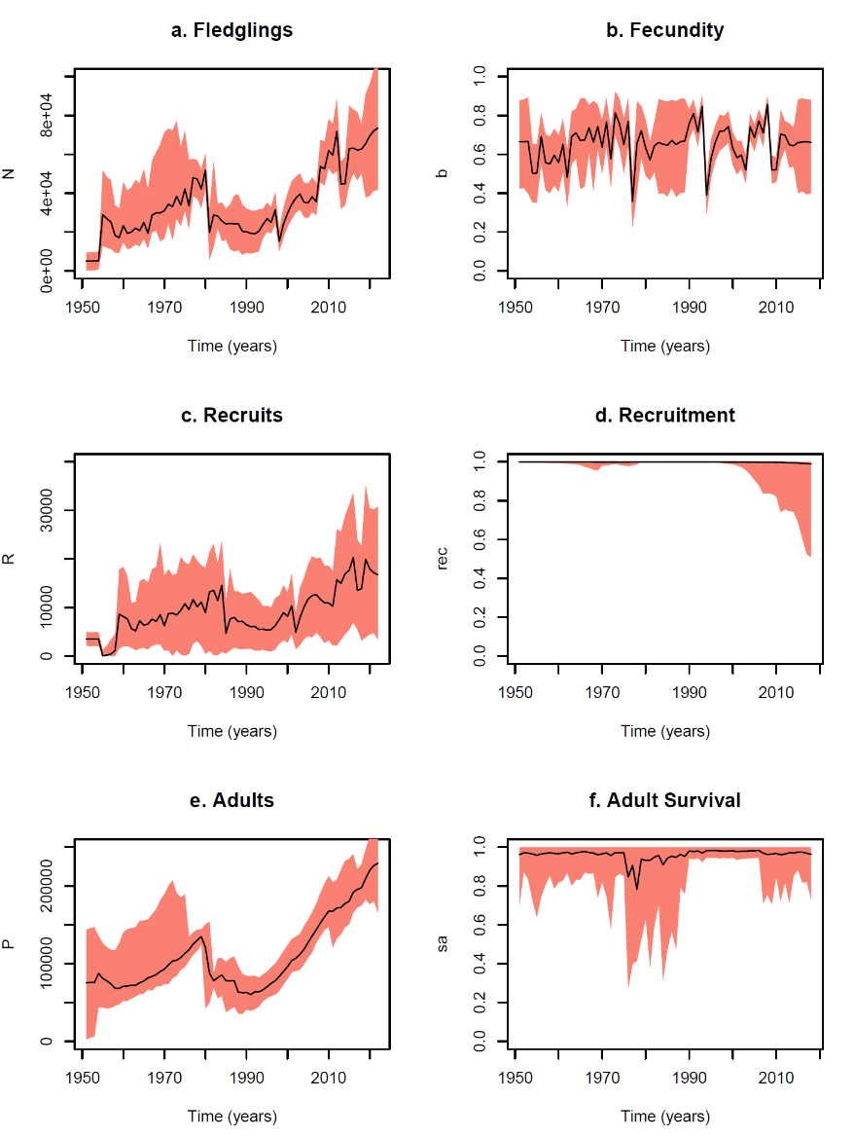

**Figure 1:** Reconstruction of population trajectories and demographic processes from the baseline model (Model 1), which contained no covariates and accepted the reported precision of historical population estimates.

## Sensitivity analysis

Details and graphical outputs for all results mentioned in this section are provided in the Technical report.

Model 2: The results indicate that the sustained recent population increases of Model 1 were entirely down to the (Inger et al. 2022.) estimate. However, this did not affect the apparent population crash at the start of the 1980s. As a direct consequence, this version of the model also suggests that recruitment is more constrained, both now and in the past.

Model 3: The results from this ad-hoc model averaging between Models 1 and 2 are more akin to the trajectories produced by Model 2. The conclusion from this is that even when offered the possibility of the higher 2022 population estimate, the model finds it easier to explain the data (subject to its mechanistic assumptions) by resorting to a lower recent population size, and a stronger density dependence.

Model 4: Doubling the CVs of all surveys gave reconstructions similar to Model 1. Therefore, even though the model was given more flexibility to ignore fluctuations in the observations, the relative magnitude of the point estimates drove it to conclude that the population is currently increasing well beyond historical levels.

Model 5: Increasing all survey CVs by a scale of 10 was such a large increase in observation uncertainty that it led the model to infer a completely flat trajectory, across the history of observation (i.e., from the point of view of inference, the population data were as good as absent).

Examination of the sensitivity of the model’s results to different assumptions about the bias and precision in the population data indicated that Model 3 is the most parsimonious. It affords some credibility to historical counts but encompasses both possibilities of a low and high count for 2022. Therefore, it was decided that Model 3 would be the most suitable vehicle for investigation of candidate covariates, forecasts and counterfactuals. Reconstructions from this model are shown in Fig. 2.

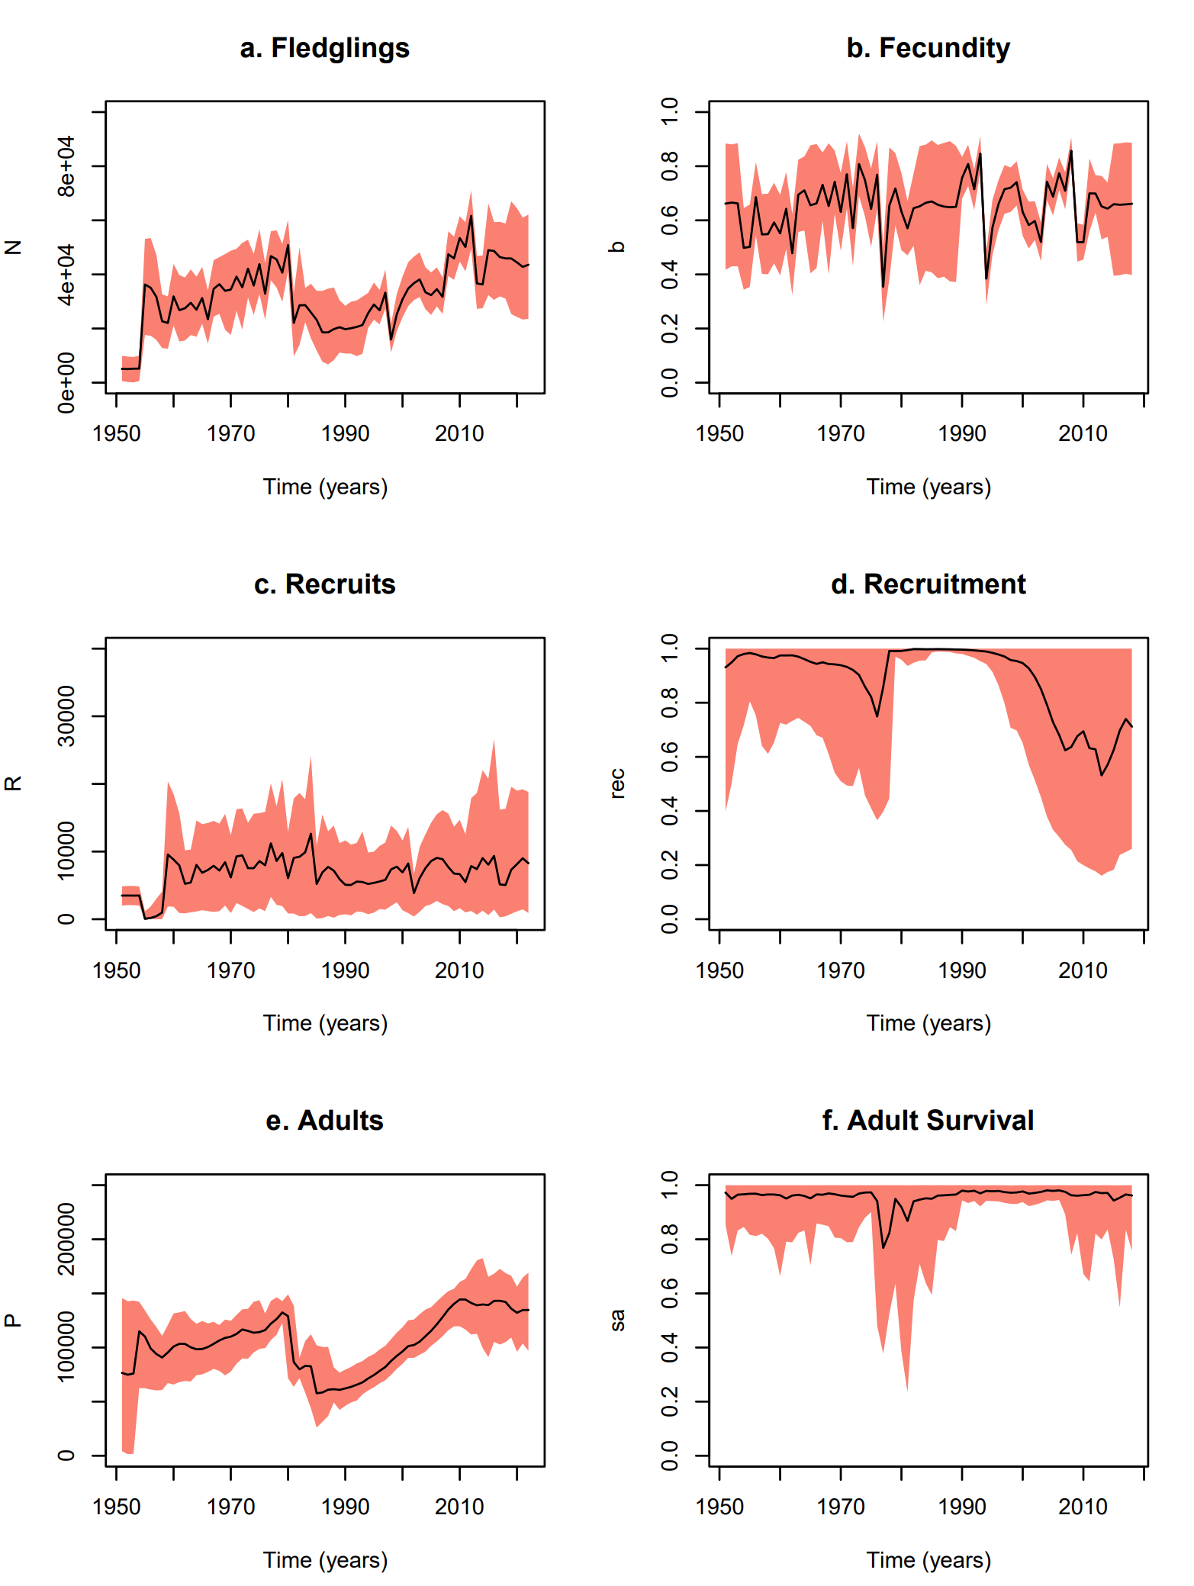

**Figure 2:** Reconstruction of population trajectories and demographic processes from the baseline model (Model 3), which contained no covariates and took a precautionary approach to the 2022 population estimate.

## Effect of covariates

The effect of rain was investigated in two versions of this model. The first version assumed that (as previously reported in (Thompson 1987; Thompson and Furness, 1991)), rain has a detrimental effect on breeding success. The second version, took a more agnostic approach, investigating whether rain could have any effect on breeding success. The first version of the model found that there was no evidence for a negative effect. The second version indicated a small positive impact. However, this effect is weak (see posterior in Fig. 3a) and certainly cannot be discerned by visually inspecting the reconstructed time series of fecundity and the corresponding rainfall time series (Fig. 3b).

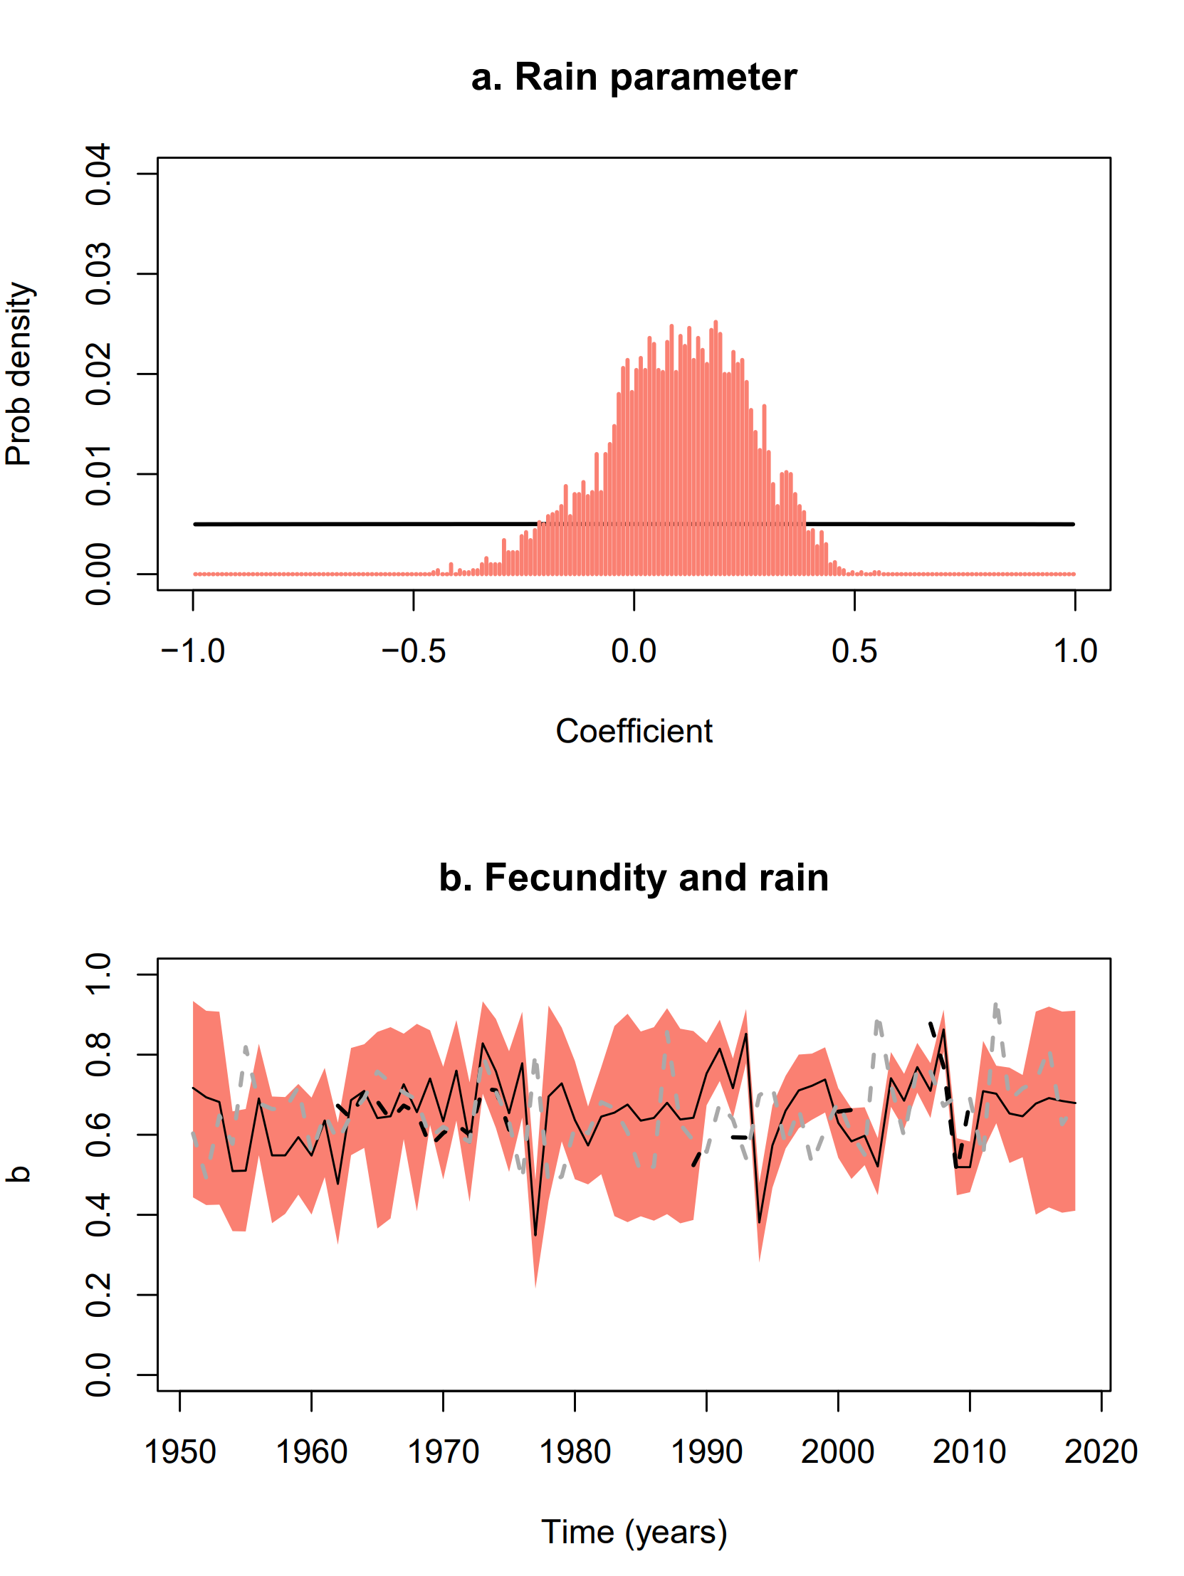

**Figure 3:** a) Comparison of the prior (flat black line) and posterior (salmon histogram) distributions for the coefficient of the rainfall covariate. b) The reconstructed fecundity time series shown together with the time series segment of Rum rainfall (black dashed line) and the longer time series of Tiree rainfall data (grey dashed lines). The rainfall data have been standardised to the mean value of the fecundity variable (the units on the y-axis), solely to allow visual comparison.

There is evidence from the neighbouring island of Canna that shearwater population declined as a result of predation of eggs and chicks by rats. However, the sparsity of data on rat abundance did not permit us to examine rat abundance as a covariate of breeding success.

## Forecasts

Effects on adult survival: The baseline scenario (Fig. 4a) was the forecast generated from the population continuing with the current regime of environmental stochasticity in all the demographic processes. Importantly, despite having generated these predictions from Model 3 (i.e., not adhering to the optimistic 2022 estimate by (Inger et al.2022)), the model predicts only a 10% chance of population reduction in the next 25 years and 8% for the next century. From that baseline we examined two scenarios of press perturbation. A 1% reduction in annual adult survival yields a small increase in decline risk (Fig.4b) but decline becomes the predominant outcome if adult survival is suppressed by 5% annually (Fig.4c). These scenarios were followed by three pulse perturbation scenarios (10%, 25% and 50% reductions in adult survival applied in 2024). The population is predicted to be completely robust to such events (Figs 4d, e & f).

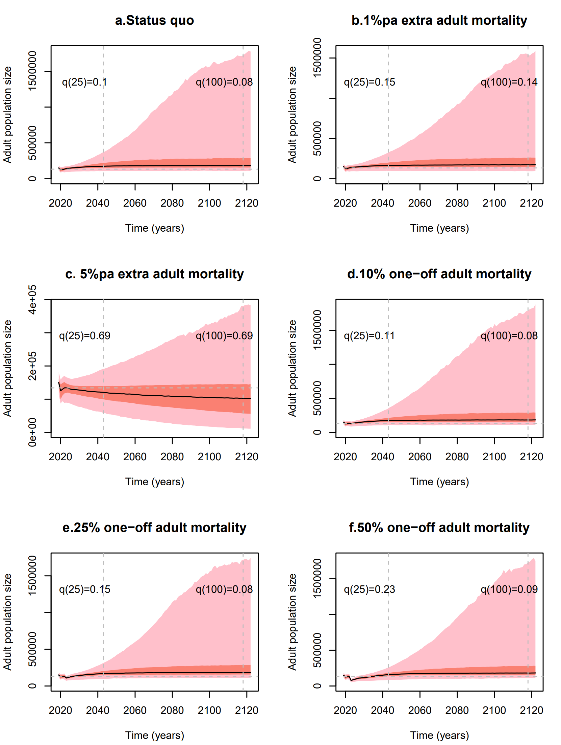

**Figure 4: Perturbation scenarios for adult survival.** The baseline scenario corresponding to the continuation of the status-quo (a) is compared with two press perturbation scenarios (b,c) and three pulse perturbation scenarios (d,e,f). Pulse perturbations were applied from 2024. The dashed lines indicate the two forecasting time horizons of 25 and 100 years, for which risk *q* is quantified. The risk here is defined as the probability that the population will be smaller than its current size at that time horizon. The pink bands indicate 95% credible intervals, and the salmon bands indicate 50% credible intervals.

Effects on fecundity: The baseline scenario (Fig. 5a) is, once again, the forecast generated from the population continuing with the current regime of environmental stochasticity in all the demographic processes. Incrementally more severe attritions on fecundity, from 10% to 50% pa (Figs 5c, d, & e) indicate that the population is quite robust to loss in reproductive capability, assuming the survival probabilities remain as they are. Equivalently, the population could survive with no lasting impact in the next 25 or 100 years if it lost half or all its fledgling cohort in 2024 (Figs 5e & f).

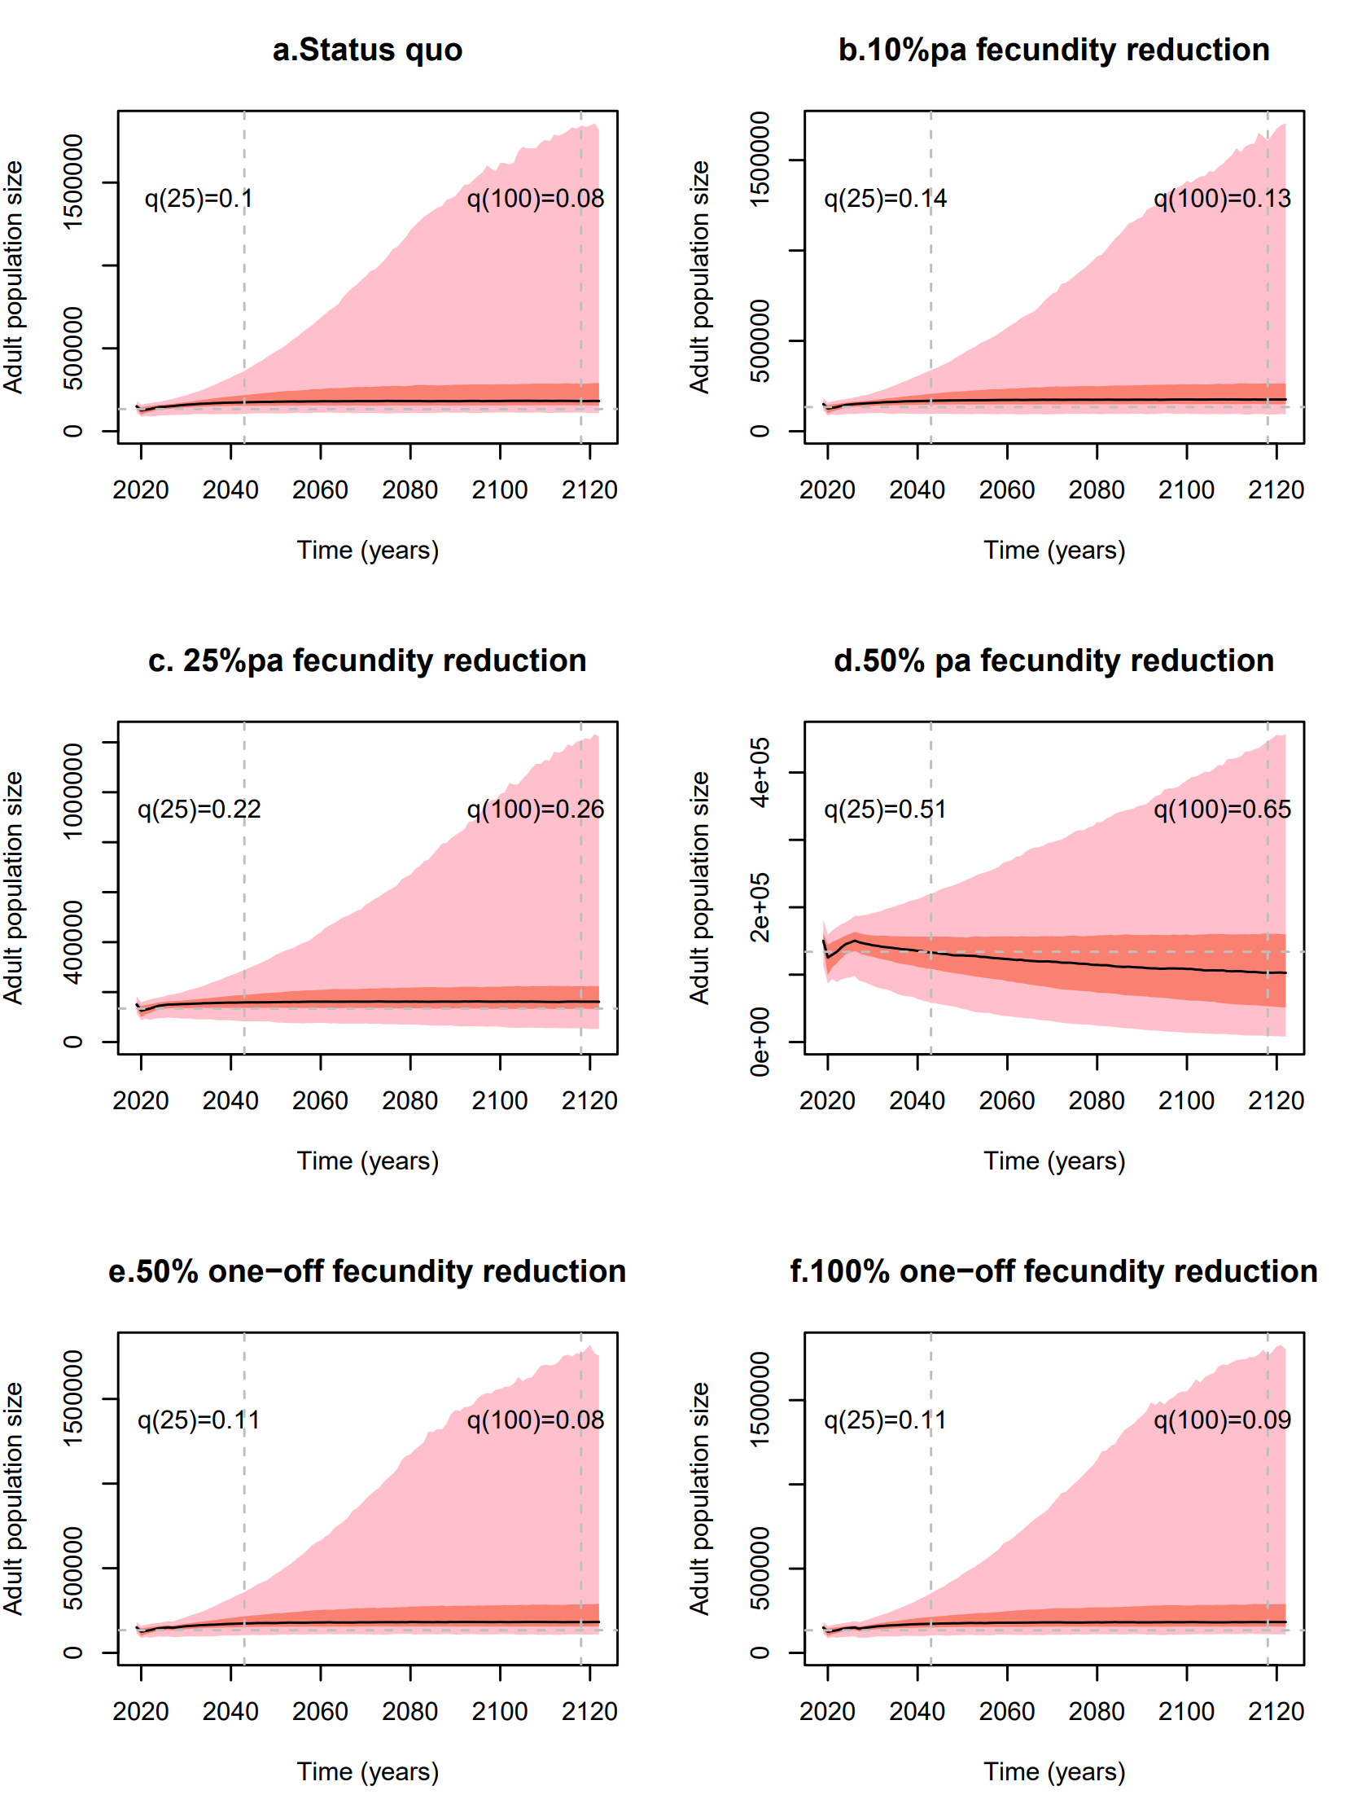

**Figure 5: Perturbation scenarios for fecundity.** The baseline scenario, corresponding to the continuation of the status-quo (a), is compared with three press perturbation scenarios (b,c,d) and two pulse perturbation scenarios (e,f). The dashed lines indicate the two forecasting time horizons of 25 and 200 years, for which risk *q* is quantified. The risk here is defined as the probability that the population will be smaller than its current size at that time horizon. The pink bands indicate 95% credible intervals and the salmon bands indicate 50% credible intervals.

# Discussion

The drivers of population size and the long-term trends of the Rum population of Manx shearwaters are complex and include both intrinsic and extrinsic variables operating within the colony and in the birds' marine range, which includes wintering and pre-breeding areas in the western Atlantic. Currently, uncertainties exist with respect to the relative importance of the various proximate population drivers (breeding success, adult survival, recruitment, immigration/emigration etc.) in determining population trends and how underlying environmental variables (including rat depredation, summer weather, winter weather, marine food supply, anthropogenic impacts etc.) interact to drive these. These uncertainties mean that it is difficult to predict population trends, a prerequisite for environmental assessments, as well as the predicted efficacy of any management interventions at the colony.

To address this uncertainty, Marine Scotland, and NatureScot, commissioned this study via the ScotMER programme to construct a robust model of the population dynamics of the Rum Manx shearwater population by applying Bayesian hierarchical modelling approaches to relevant available data. In doing so, this project aimed to provide vital information that will help support the sustainable development of offshore wind whilst also protecting Scotland’s unique marine environment.

The fully-fitted, user-friendly and computationally efficient R-functions for generating these projections are available with the deliverables of this project. Future work could design more systematic factorial designs for investigating impacts on this population. Alternatively, case-specific questions can be asked if the exact profile of impacts for a particular development is known. In addition to producing a robust prediction tool for forecasts and counterfactuals, this project has reached several valuable conclusions that may be useful for future data collection or the management of impacts on the population. Specifically:

Available population and demographic data are sufficient to fit an informative population model for the internationally important Manx shearwater population on the isle of Rum. The model can reconstruct past trends and provide informative predictions and scenario counterfactuals over periods of decades.

It is less clear whether the available data can inform us about the current strength of density dependence and potential consequences for recruitment. A detailed model of successively relaxing density dependence is described in the technical report, but the available data do not allow it to be embedded in the state-space model.

It is equally not clear whether the model can detect trends in response to covariates. The original ambition was that once the state-space model had decomposed the observed dynamics into individual demographic trajectories, it would become easier for the model to detect correlations with covariates. In the case of the one covariate (rainfall) for which data and prior knowledge existed to do this, the results were not conclusive. Other covariates (such as rat density) were not examinable due to data-sparsity.

Importantly, the simulation trials with this model, replicating the exact availability (types, sample sizes and time instances) of the real data, indicated that retrieval of information on density dependence and covariates may currently prove challenging.

Investigation of the sensitivity on the precision and bias of population estimates indicates that precision is less influential than bias. So, any additional data collection effort may better be spent in accurately mapping the shearwater greens, rather than increasing effort within well studied areas (i.e., spatial extent is probably preferable to local replication).

Low and intermediate population estimates for 2022 give similar results, indicating a robust family of models.

While the survey methods remain unstandardised, the precautionary modelling approach is to proceed with a model that permits both over- and under-estimation of the current population. This is based on the facts that the (Inger et al. 2022) report did not validate the habitat modelling approach (potential upward bias) and did not propagate analysis uncertainty to final results (potential over-representation of precision).

Predictions from the fitted model anticipate a mostly stable population under the status-quo.

Press perturbations seem to be capable of turning the population to a declining trend. For example, a 5% annual reduction in adult survival leads to a 69% chance of decline over the next 25 and 100 years, whereas a more drastic (50%) annual reduction in fecundity would be required for a similar outcome.

Subsequently, from these indicative and highly selective investigations, we conclude that the population would be most vulnerable to long-term but modest reductions in the survival of breeders.

The strategy taken here to model environmentally induced variation was to start by associating an annually varying random effect to each demographic process. In this way, even though the baseline models did not contain extrinsic covariates, we were able to capture the levels of variability in each demographic process. This offers an advantage for forecasting, because covariate time series are, by default, historical data and are not known in the future. Our random effects are built-in to the forecasts and subsequent sensitivity conclusions drawn from this study. Hence, sensitivity here is concluded not just as the result of deterministic strength of one demographic process over another, but also upon their relative levels of stochastic variation.

Nevertheless, the stated objective of the project funders was to have a framework that can investigate proximate covariates. Technically, this task can be thought of as an apportioning of the empirically inferred dispersion (the random effects), into the contributions of covariates. We began this process here by looking at rainfall.

The finding that rainfall did not appear to have a negative impact on breeding success is contradictory to previous work by (Thompson 1987; Thompson and Furness, 1991) as well as the intuition of several experts who have worked on this population on Rum. The inferential approach to looking at this relationship is different here compared to previous work. The model essentially reconstructs the time series of breeding success across the full duration of the study and simultaneously draws on information from Rum and Tiree, to get a more complete picture of rainfall across the years. Fig. 3a indicates that rainfall is a weak covariate of breeding success. It may be that the relationship derived by previous workers, based as it was on a shorter segment of time, was in fact spurious. Alternatively, it may be that the reconstruction of breeding success in the present model is accounting for the effects of missing covariates, other than rainfall, that have a confounding effect. Or the effect of rainfall may require analysis of daily rainfall data rather than monthly totals as used in this study, in order to identify rare events of exceptional levels of rainfall. Finally, it may be that the linear incorporation of monthly totals of rainfall into our model was too simplistic to capture the physical processes of burrow flooding. For example, if optimal burrows characterised by a low risk of flooding are occupied first by breeders, then it is likely that the effects of flooding will be felt only in high-density populations where individuals are forced to occupy high-risk burrows.

From a modelling perspective, it is now straightforward to include additional covariates, on the condition that the covariate time series are sufficiently complete and that there is enough population survey data to detect correlations. Neither of these requirements currently holds, but it is important to catalogue here possible extensions with additional influential covariates.

The sparsity of data on rat abundance did not permit us to examine rat abundance as a covariate of breeding success, but this should be a monitored variable for future investigations with this model. On Canna (which can be considered a small offshoot of the Rum colony) the Manx shearwater population declined because of predation of eggs and chicks by rats. However, the rats on Rum do not seem to have a similar effect on the shearwaters. On Rum, the colony is unusual in that shearwaters nest about 1000 feet above sea level at the tops of the Rum hills but the colony may previously have also extended to lower altitudes. In addition, having burrows in the well-drained gravelly ground of the hilltops made burrows less prone to flooding during heavy rain (Thompson 1987, Lambert et al. 2021). Data availability for rats is very limited on Rum, covering the period 2010-13, which critically, does not overlap with the availability of data on breeding success. Nevertheless, it seems that there is something specific to Rum which until now has prevented the growth of a rat population to a sufficiently large size that could drive shearwater population decline. That could potentially be winter cold in the colony area limiting rat numbers.

Additional information on weather-related variables, such as days of frost and climate-related variables, such as sea-surface temperature and the North Atlantic oscillation have previously been used (Thompson and Furness 1991, Duff 2011) and could be examined again as determinants of adult survival in the present more integrated approach. The availability of those varies but can go as far back as 1958. Wood et al. (2021) found a significant correlation between adult survival at Skomer and wind strength. However, the annual variation in survival estimates at Rum is very small for the available series of years (varying only between 0.975 and 0.986 over the period 1994-2011) so the possibility to detect such covariate effects will be limited. Wood et al. (2021) were unable to find any environmental covariates that correlated significantly with breeding success of Manx shearwaters at Skomer. Note however that fledgling weights, as well as chick survival to fledging, are also important with respect to future survival and are affected by timing of breeding. Recent tracking work from Skomer suggests that pre-laying females forage in very different locations from adults later in the season provisioning young (Tim Guilford, pers. comm.). Taken together, this may indicate that there could be particular spring conditions within which females find it more challenging to accumulate the resources needed for egg production, resulting in delay to laying dates, which in turn will impact chick fledging dates and weights with associated impact on post-fledging survival.

If rat depredation is a factor impacting breeding success, there could potentially be a weather-related effect whereby harsher winters might be anticipated to reduce rat population within the colony. However rainfall conditions in the preceding spring might also be a factor, such that in years with high levels of egg mortality associated with burrow flooding there may be more food supplies within the colony to sustain scavenging rats over the winter period. Incidentally, this is also the reason for added concern around HPAI impacts and possibility of large-scale associated breeding failure, through either direct mortality of chicks or indirect mortality through adult mortality resulting in chick starvation, leading to a super-abundant winter food supply that could sustain a rat population in the colony area over winter and drive high depredation of eggs/chicks in the subsequent breeding season.

Fishing productivity, has previously been used to explore effects on adult breeding success (Duff 2011), but Manx shearwaters do not normally scavenge at fishing boats and their prey is not generally subject to fishing mortality in the west of Scotland waters. Disease, most recently, the occurrence of High Pathogenicity Avian Influenza on Rum, is expected to impact the population and estimates are currently being produced for the annual mortality during the outbreak. Finally, the impact of marine renewable developments can only currently be investigated by scenario exploration (similar to the forecasts produced here). However, such scenarios could be made more realistic by distinguishing between the impact of construction (a pulse perturbation) and operation (a press perturbation) as well as the postulated effects on multiple demographic processes simultaneously. The models developed in this work, using the entirety of available data on this population offer a valuable baseline against which the effects of anthropogenic developments can be assessed.

# Data and code availability

All relevant files can be found at https://github.com/JasonMat/ManxRum.

# References

Bender, E. A., T. J. Case, and M. E. Gilpin. 1984. Perturbation experiments in community ecology: theory and practice. Ecology 65:1–13.

Bolton, M., and K. R. Thompson. 2023. Manx shearwater – Puffinus puffinus. Page Seabirds Count: a census of breeding seabirds in Britain and Ireland (2015-2021). Lynx Nature Books, Barcelona.

Booker, H., D. Price, T. Taylor, and S. View. 2008. Manx Shearwater Breeding Success on Lundy 2007.

Brooke, M. D. L. 1977. The breeding biology of the Manx shearwater.

Brooke, M. D. L. 1978. Some Factors Affecting the Laying Date, Incubation and Breeding Success of the Manx Shearwater, Puffinus puffinus. The Journal of Animal Ecology 47:477.

Buckland, S. T., K. B. Newman, C. Fernández, L. Thomas, and J. Harwood. 2007. Embedding population dynamics models in inference. Statistical Science 22:44–58.

Burnell, D., A. J. Perkins, S. F. Newton, M. Bolton, T. D. Tierney, and T. E. Dunn. 2023. Seabirds Count. Lynx, Barcelona.

Deakin, Z., A. S. C. P. Cook, F. Daunt, A. McCluskie, N. Morley, E. Witcutt, L. Wright, and M. Bolton. 2022. A review to inform the assessment of the risk of collision and displacement in petrels and shearwaters from offshore wind developments in Scotland. Page 140. Marine Directorate.

Duff, A. 2011. Population ecology of the Manx shearwater (Puffinus puffinus) on the Island of Rum, Scotland. MSc, Edinburgh Napier University.

Fieberg, J. R., K. W. Shertzer, P. B. Conn, K. V. Noyce, and D. L. Garshelis. 2010. Integrated Population Modeling of Black Bears in Minnesota: Implications for Monitoring and Management. PLoS ONE 5:e12114.

Furness, R. W. 1990. Nature Conservancy Council CSD Report No. 1168. Nature conservancy.

Furness, R. W. 1997. A 1995 Survey of the Rum Manx Shearwater Population. Scottish Natural Heritage.

Guilford, T., O. Padget, S. Bond, and M. Syposz. 2019. Light pollution causes object collisions during local nocturnal manoeuvring flight by adult Manx Shearwaters Puffinus puffinus. Seabird Journal 31:48–55.

Harris, M. P. 1966. Age of return to the colony, age of breeding and adult survival of Manx Shearwaters. Bird Study 13:84–95.

Horswill, C., and R. A. Robinson. 2015. Review of Seabird Demographic Rates and Density Dependence (JNCC Report No. 552). Page 126.

Horswill, C., R. H. Walker, E. M. Humphreys, and R. A. Robinson. 2016. Review of mark-recapture studies on UK seabirds that are run through the BTO’s Retrapping Adults for Survival (RAS) network.

Inger, R., R. Sherley, J. Lennon, N. Winn, N. Scriven, L. Ozsanlav-Harris, and S. Bearhop. 2022. Surveys of Breeding Cliff-nesting Seabirds, Ground-nesting Seabirds and Burrow-nesting Seabirds in Western Scotland. Marine Scotland.

Lambert, M., S. Carlisle, I. Cain, A. Douse, and L. Watt. 2021. Unexpected involvement of a second rodent species makes impacts of introduced rats more difficult to detect. Scientific Reports 11:19805.

Matthiopoulos, J., L. Cordes, B. Mackey, D. Thompson, C. Duck, S. Smout, M. Caillat, and P. Thompson. 2014. State-space modelling reveals proximate causes of harbour seal population declines. Oecologia 174:151–162.

Maunder, M. N., and A. E. Punt. 2013. A review of integrated analysis in fisheries stock assessment. Fisheries Research 142:61–74.

Mavor, R. A., M. Heubeck, S. Schmitt, and M. Parsons. 2006. Seabird numbers and breeding success in Britain and Ireland, 2006.

Miller, J. A. O., R. W. Furness, M. Trinder, and J. Matthiopoulos. 2019. The sensitivity of seabird populations to density-dependence, environmental stochasticity and anthropogenic mortality. Journal of Applied Ecology:2118–2130.

Mitchell, P. I., S. F. Newton, N. Ratcliffe, and T. E. Dunn. 2011. Seabird Populations of Britain and Ireland.

Murray, S., M. C. Shew, G. P. Mudge, and S. Spray. 2003. A survey of Manx shearwaters Puffinus puffinus on Rum, Inner Hebrides in 2001. Atlantic seabirds 5:89–130.

Newman, L., F. Blockley, J. Hewitt, and M. Wood J. 2021. Seabird monitoring on Skomer Island 2021. The Wildlife Trust of South and West Wales.

Perrins, C. M. 2014. Factors affecting survival of fledgling Manx Shearwaters Puffinus puffinus.

Perrins, C. M., M. P. Harris, and C. K. Britton. 1973. Survival of Manx Shearwaters Puffinus puffinus. Ibis 115:535–548.

Philips, B. 1982. A study of the Manx shearwater population on Rhum. Unpubl. MSc Thesis., University College London.

Smith, S., G. Thompson, and C. M. Perrins. 2001. A census of the Manx Shearwater *Puffinus puffinus* on Skomer, Skokholm and Middleholm, west Wales. Bird Study 48:330–340.

Syposz, M. 2020. The effect of light pollution on orientation in Manx shearwaters (Puffinus puffinus). Oxford.

Thompson, D. E. A., and P. S. Thompson. 1980. Breeding Manx shear- waters Puffinus puffinus on Rhum. Hebridean Naturalist 4:54–64.

Thompson, K. R. 1987. The Ecology of the Manx Shearwater Puffinus puffinus on Rhum, West Scotland.

Thompson, K. R., and R. W. Furness. 1991. The influence of rainfall and nest‐site quality on the population dynamics of the Manx shearwater Puffinus puffinus on Rhum. Journal of Zoology 225:427–437.

Wood, M. J., C. Canonne, A. Besnard, S. Lachish, S. M. Fairhurst, M. Liedvogel, D. Boyle, S. C. Patrick, S. Josey, H. Kirk, B. Dean, T. Guilford, R. M. McCleery, C. M. Perrins, and C. Horswill. 2021. Demographic profiles and environmental drivers of variation relate to individual breeding state in a long-lived trans-oceanic migratory seabird, the Manx shearwater. PLOS ONE 16:e0260812.

Wormell, P. 1976. The Manx Shearwaters of Rhum. Scottish Birds:103–118.

Zipkin, E. F., and S. P. Saunders. 2018. Synthesizing multiple data types for biological conservation using integrated population models. Biological Conservation 217:240–250.